**What is a Firewall?**

A firewall is a network security device or software that acts as a barrier between a trusted network (like your organization's internal network or your personal computer) and untrusted networks (typically the internet). Its primary function is to monitor and control incoming and outgoing network traffic based on an organization's predefined security rules or policies.

**1. Packet Filtering:** Firewalls inspect data packets as they travel between devices or networks. They examine factors like source and destination IP addresses, port numbers, and the protocol used (e.g., TCP, UDP) to determine whether to allow or block a packet.

**2. Stateful Inspection:** Many modern firewalls use stateful inspection, which not only looks at individual packets but also keeps track of the state of active connections. This allows the firewall to make more informed decisions about allowing or blocking traffic based on the context of the entire communication.

**3. Access Control:** Firewalls use access control rules to determine which network traffic is allowed and which is denied. These rules are defined based on security policies and can specify who (or what) can access specific resources on the network.

**4. Proxy Services:** Some firewalls offer proxy services, acting as an intermediary between the internal network and external resources. This can enhance security by inspecting and potentially modifying traffic between the two.

**5. Network Address Translation (NAT):** Firewalls often use NAT to hide the internal IP addresses of devices from external networks. This provides an additional layer of security and privacy.

**6. Application Layer Filtering:** Advanced firewalls can inspect traffic at the application layer (Layer 7 of the OSI model), allowing them to make decisions based on the specific application or service being used (e.g., HTTP, FTP, email).

**7. Intrusion Detection and Prevention:** Some firewalls include intrusion detection and prevention features to identify and block potentially malicious traffic patterns or behavior.

**8. Virtual Private Network (VPN) Support:** Many firewalls support VPNs, allowing secure remote access to the internal network over the internet.

**9. Logging and Reporting:** Firewalls typically maintain logs of network activity, which can be critical for auditing and monitoring security incidents.

**10. Alerts and Notifications:** Firewalls can be configured to generate alerts or notifications when suspicious or unauthorized activity is detected.

**Basic comparison and installation of a software firewall.**

**Practical: Basic comparison and installation of a software firewall.**

Endian Firewall Community is an open-source software firewall and Unified Threat Management (UTM) solution designed to provide network security features for small to medium-sized businesses and home users. It's based on the Linux operating system and offers a range of security features. Please note that as of my last knowledge update in September 2021, I can provide an overview of Endian Firewall. Be sure to check for any updates or changes in the software since then.

**Key Features of Endian Firewall Community:**

1. **Firewall:** Endian Firewall includes a stateful packet inspection (SPI) firewall, which allows you to define rules for controlling network traffic, including blocking or allowing specific ports, protocols, and IP addresses.
2. **Proxy Services:** It offers proxy services for HTTP, HTTPS, and FTP, enabling content filtering and caching, which can enhance network performance and security.
3. **VPN (Virtual Private Network):** Endian supports various VPN protocols like OpenVPN and IPsec, making it suitable for secure remote access and connecting remote offices.
4. **Intrusion Detection and Prevention (IDP):** The firewall includes IDP capabilities to detect and prevent suspicious or malicious network activities.
5. **Gateway Antivirus:** Endian Firewall has an integrated antivirus engine that can scan incoming and outgoing traffic for malware and viruses.
6. **Spam Filtering:** It provides spam and email filtering capabilities to help reduce unwanted emails and protect against phishing attacks.
7. **Web Filtering:** The web filter allows you to block or allow specific websites or categories of websites, enhancing web security and productivity.
8. **Traffic Shaping:** You can prioritize or restrict bandwidth for specific types of traffic or applications, ensuring that critical services get the required resources.
9. **Logging and Reporting:** The firewall generates logs and reports on network activities, helping you monitor and analyze your network's security.
10. **User Authentication:** Endian supports user authentication methods, including integration with LDAP or Active Directory, to control access to the network.
11. **High Availability (HA):** It offers high availability options for redundancy and failover to ensure continuous network operation.

**Endian Firewall Community vs. Enterprise Edition:** The Community edition of Endian Firewall is free and open-source, while the Enterprise edition offers more advanced features and support options for larger organizations. The Community edition can be a good starting point for small businesses or individuals looking to implement a basic firewall solution.

To get started with Endian Firewall Community, you can visit the official website or community forums for installation guides, documentation, and community support. Keep in mind that the software and its features may have evolved since my last update in September 2021, so it's a good idea to check for the latest information and releases on the Endian website.

**How Firewalls Work**  
  
Endian Firewalls work by providing a protective barrier between your internal network (LAN) and the external world (usually the internet). They control and monitor traffic moving in and out of your network to ensure that only authorized and safe data flows through. Here's a general overview of how an Endian Firewall operates:

1. **Packet Inspection:** When data packets enter your network from external sources or leave your network to access external resources, the Endian Firewall intercepts and inspects them. It checks each packet against predefined rules and policies.
2. **Firewall Rules:** The firewall operates based on a set of rules you define. These rules dictate what is allowed and what is denied. For example, you can create rules that allow HTTP (web) traffic but block FTP (file transfer) traffic.
3. **Stateful Packet Inspection (SPI):** Endian Firewalls often employ stateful packet inspection, which means they keep track of the state of active connections. This allows the firewall to make more informed decisions about allowing or blocking traffic. For example, it can recognize that an incoming data packet is part of an established, legitimate connection and allow it.
4. **Proxy Services:** Endian Firewalls can act as proxies for certain types of traffic, such as HTTP, HTTPS, and FTP. This means they can intercept and handle requests and responses for these services. Proxy services are commonly used for content filtering, caching, and enhancing security.
5. **VPN and Tunneling:** Endian Firewalls support VPN (Virtual Private Network) technologies, allowing secure communication between remote locations or users and your network. VPNs encrypt data as it travels over the internet, enhancing privacy and security.
6. **Intrusion Detection and Prevention (IDP):** Endian Firewalls can include intrusion detection and prevention systems that monitor network traffic for suspicious patterns or known attack signatures. If an intrusion is detected, the firewall can take actions such as blocking the offending IP address.
7. **Gateway Antivirus:** Some Endian Firewalls come with integrated antivirus capabilities. They scan incoming and outgoing traffic for malware and viruses, blocking or quarantining infected files.
8. **Spam and Email Filtering:** Endian Firewalls can filter email traffic to identify and block spam emails and potentially malicious attachments, helping to reduce the risk of phishing and other email-based attacks.
9. **Web Filtering:** Web filtering features allow you to control and monitor internet access by blocking specific websites or categories of websites. This helps enforce acceptable use policies and enhance security.
10. **Logging and Reporting:** The firewall generates logs and reports that provide insight into network activity, policy violations, and security incidents. These logs can be crucial for monitoring and auditing purposes.
11. **User Authentication:** Many Endian Firewalls support user authentication, allowing you to control access to the network based on user credentials. This can be essential for ensuring that only authorized users gain access to sensitive resources.

Overall, Endian Firewalls combine multiple layers of security measures to protect your network from threats originating from the internet while also controlling and securing outgoing traffic. Proper configuration, regular updates, and monitoring are crucial to maintaining effective network security using an Endian Firewall.

Practical Firewall configuration endian   
  
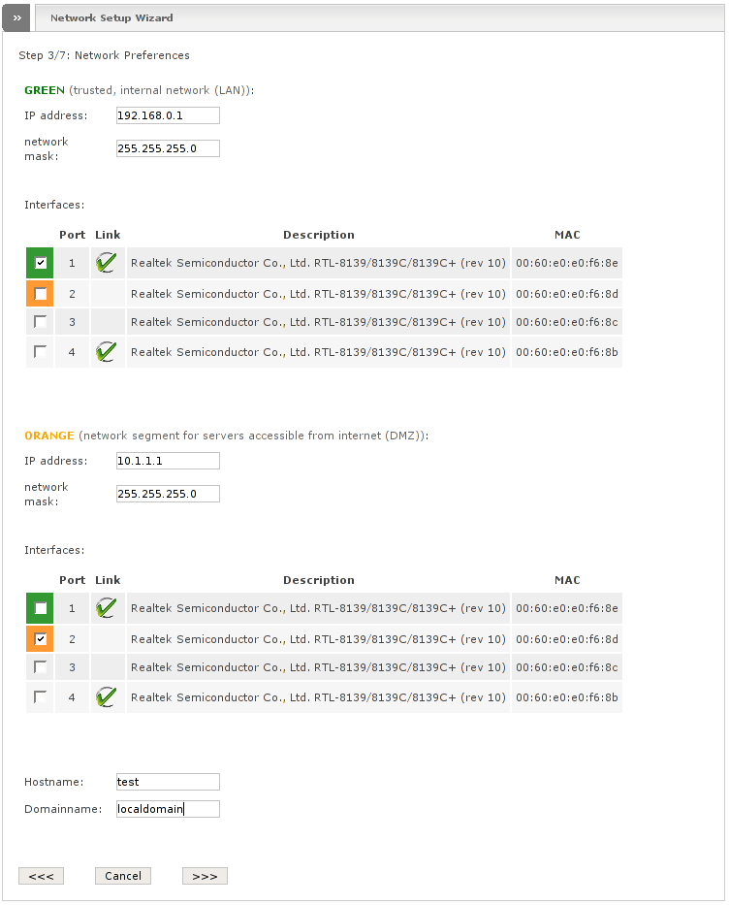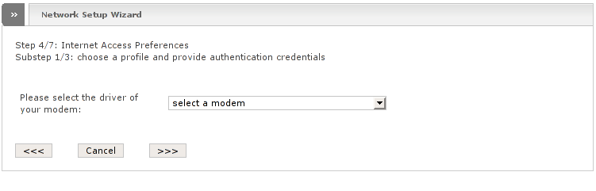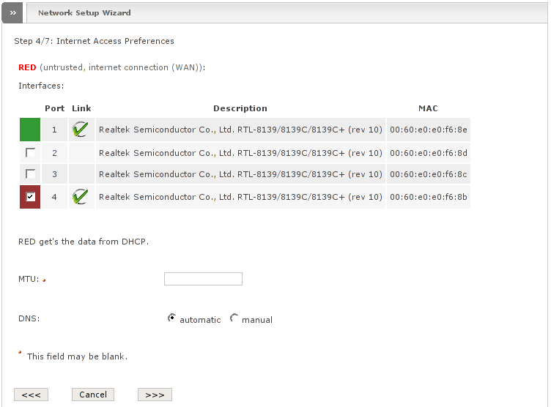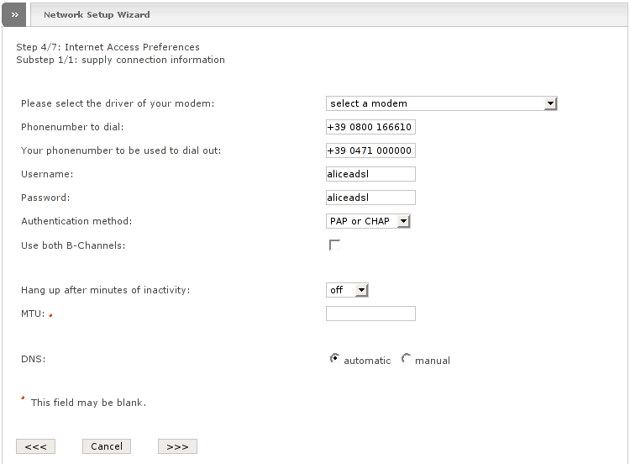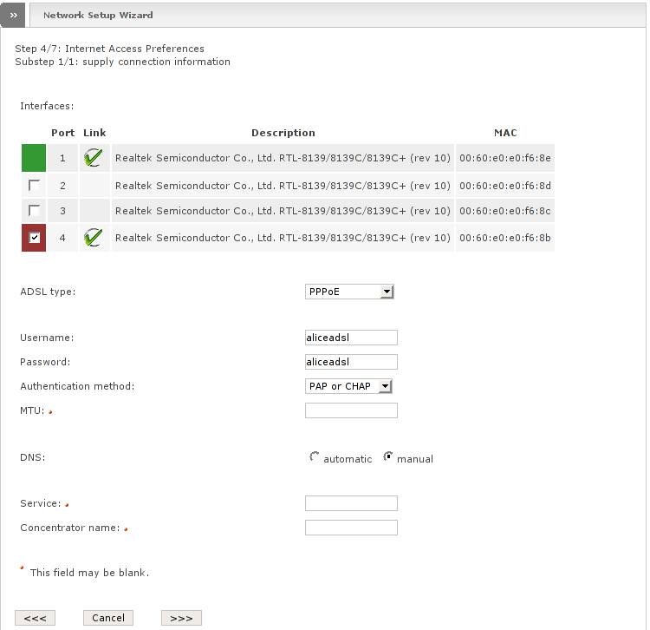

**Additional Resources  
  
  
installation :** <https://www.youtube.com/watch?v=f2gPg0_8dLw> **configuration :** <https://www.youtube.com/watch?v=Jlv9sgmgr4k&t=965s> **Network Desing  
  
Minimizing Downtime:** Network failures or issues can disrupt business operations, leading to downtime that can result in financial losses. Efficient troubleshooting helps reduce downtime by identifying and resolving problems promptly.

1. **Ensuring Network Reliability:** Networks are the backbone of modern businesses, supporting critical operations, communication, and services. Troubleshooting ensures that networks operate reliably, preventing service interruptions.
2. **Optimizing Performance:** Networks can experience performance bottlenecks or slowdowns due to various factors. Troubleshooting helps identify and address these issues, ensuring optimal network performance and user satisfaction.
3. **Security Enhancement:** Network issues, such as vulnerabilities or breaches, can compromise data security. Effective troubleshooting helps detect and mitigate security threats, safeguarding sensitive information.
4. **Resource Efficiency:** Network troubleshooting helps identify and resolve problems related to resource allocation, such as bandwidth usage or device connectivity. This optimizes resource utilization and reduces waste.
5. **Cost Savings:** Timely troubleshooting can prevent the need for expensive network upgrades or hardware replacements. It can also prevent losses resulting from security breaches or prolonged downtime.
6. **Customer Satisfaction:** In the context of service providers, efficient troubleshooting ensures customer satisfaction by resolving service-related issues promptly. Happy customers are more likely to remain loyal.
7. **IT Professional Skillset:** Troubleshooting is a fundamental skill for IT professionals. Developing strong troubleshooting skills is essential for career growth and success in IT and networking roles.
8. **Continuous Improvement:** Through the troubleshooting process, organizations can gather insights into network performance and reliability, enabling them to make informed decisions for continuous improvement and future upgrades.
9. **Preventing Future Issues:** Effective troubleshooting often involves identifying root causes. By addressing these root causes, organizations can prevent similar issues from recurring in the future.
10. **Compliance and Regulation:** Many industries have specific regulatory requirements related to data security and network reliability. Troubleshooting helps ensure compliance with these regulations, avoiding legal and financial consequences.

**Business Continuity:** In cases of disaster recovery and business continuity planning, troubleshooting expertise is crucial to quickly restore network services in the event of a catastrophe.  
  
• **Identify the Problem:**

* The first step is to define the problem clearly. Gather information from users or monitoring systems to understand the symptoms and their impact on the network or system. Ask questions to pinpoint the issue's nature and scope.

• **Gather Information:**

* Collect data and relevant information about the network and the problem. This may include network diagrams, logs, error messages, and the affected devices or systems. Ensure that you have a clear understanding of the network's configuration.

• **Isolate the Problem:**

* Determine if the issue is localized or widespread. This involves identifying whether the problem affects a single user, a specific segment of the network, or the entire network. Isolating the problem helps focus troubleshooting efforts.

• **Check Physical Connections:**

* Inspect physical connections, cables, and hardware components. Loose cables or faulty hardware can often cause network issues. Ensure that all devices are properly powered on and connected.

• **Review Configuration Settings:**

* Examine network device configurations, including routers, switches, and firewalls. Verify that settings are correct, and compare them to known working configurations if available.

• **Use Diagnostic Tools:**

* Employ network diagnostic tools such as ping, traceroute, and network monitoring software to test connectivity and gather additional data about the problem. These tools can help identify where issues are occurring.

• **Test in Layers:**

* Follow the OSI model layers (Physical, Data Link, Network, Transport, etc.) and test each layer individually. This helps narrow down the scope of the problem and identify the specific layer causing the issue.

• **Review Logs and Error Messages:**

* Examine logs and error messages on networking devices and servers. These logs often contain valuable information about the root cause of network problems.

• **Consider Recent Changes:**

* Investigate whether any recent changes to the network, such as configuration updates or software installations, might have triggered the problem. Rollback recent changes if necessary.

• **Consult Documentation and Resources:**

* Refer to vendor documentation, online forums, and knowledge bases for information related to the specific issue. Other IT professionals' experiences can provide valuable insights.

• **Isolate the Faulty Component:**

* Use a process of elimination to identify the component causing the problem. Disconnect or disable suspected components one at a time and test the network after each change.

• **Implement Solutions:**

* Based on your findings, implement the necessary solutions or fixes. This may involve reconfiguring settings, replacing hardware, or applying software updates.

• **Verify Resolution:**

* Confirm that the problem has been resolved by testing the network thoroughly. Ensure that all affected users or systems are functioning correctly.

• Document **the Process:**

* Maintain detailed records of the troubleshooting process, including the steps taken, changes made, and the ultimate resolution. This documentation can be valuable for future reference and knowledge sharing.

• Communicate **with Stakeholders:**

* Keep stakeholders informed throughout the troubleshooting process. Provide updates on progress and inform them when the issue has been resolved.

• Follow **Up:**

* Periodically check the network to ensure that the issue does not reoccur. Analyze the problem's root cause to prevent similar issues in the future.

**Network Monitoring Software:**

* **Wireshark:** A powerful network protocol analyzer that allows you to capture and inspect data packets on your network. It can help diagnose network issues, identify anomalies, and pinpoint the source of problems.
* **Nagios:** An open-source monitoring system that can track network services, hosts, and their states. It provides alerts and notifications when issues are detected.

**Command-Line Utilities:**

* **Ping:** This utility is used to test network connectivity between two devices. It sends ICMP (Internet Control Message Protocol) echo requests and measures the response time.
* **Traceroute (or traceroute6 for IPv6):** Helps trace the route that packets take from your computer to a destination, showing each hop along the way. This can be useful for identifying network bottlenecks or failures.
* **ipconfig (Windows) / ipconfig (Linux):** These commands display network configuration information for your computer, including IP addresses, subnet masks, and gateway addresses.

**Hardware Diagnostic Tools:**

* **Loopback Plugs:** These are physical devices that can test the network interface cards (NICs) on computers by creating a loopback connection. This helps diagnose NIC issues.
* **Cable Testers:** Used to check the integrity of network cables by sending signals through them to detect faults or breaks in the cable.
* **Network Analyzers:** Hardware tools that provide in-depth analysis of network traffic and can help identify issues with physical components.